**National Association of American Veterans**

**4th Quarter Testimonials**

**Oct. Nov. Dec. 2024**

Transitioning from the leaves of change into a new and afresh season, be it according to thine will, Lord God. Christmas season sparks festive, vibrant lights, music, and cheer, but only after the leaves have fallen to the ground. We can’t forget what the fall produced… What man has lost and gained. Jesus came into this world as a gift… For unto us a Child is born… and He left this earth as a Savior given. He arose. He lived. He died. And, He’s coming back again.

All of the past seasons have come and gone. Fall leaves have fallen soon to usher in a cold and freezing covering called winter. A preserving phase… A time to huddle close, slow down and reflect. Out with the old—in with the new.

The **National Association of American Veterans (NAAV, Inc.)** has stepped into each season this year with both change and challenges. As we make our way through the end of this year, we would like to share a few of the last miraculous testimonies sent from above, sort of a like the announcement from the Angel Gabriel to Mary that she would be with child as a virgin… “How can this be…?” NAAV is well aware of how these few testimonies came to be – with your support, prayers, and partnership lives were spared, hope was renewed and joy was felt.

Let the trumpets sound – behold we bring good tidings this season and trust to do the same into the coming new year as we share closing end of fall/winter testimonies:

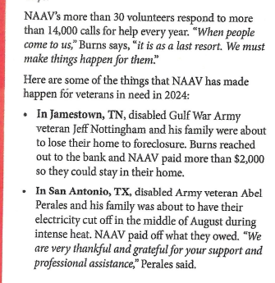*CharityChoices.com

* October: *Shelter in times of storm*

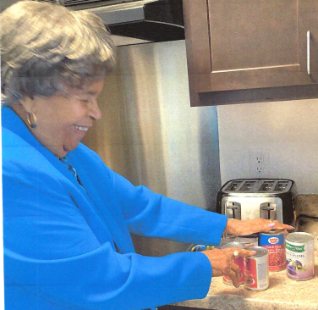 *Serving retirement home residence around the DMV. Continue to support CFC…



* Late entry from September’s testimonies, is no less than what NAAV continues to do by serving American Veterans and their family members in every one… With arms wide opened:

"*Greetings,  
 I am extremely grateful for Ms. Constance A. Burns, President and  
 CEO, NAAV, Inc. expertise in helping to obtain information about my  
 deceased husband’s headstone and receiving certified honor  
 certificates from our current President Joe Biden. I appreciate her  
compassion, thoughtfulness, and kindness. May God bless her for the*

*Love she shows to those who are in bereavement."* -- **Lillie P. Lindsey, Daughter, of Louis Lindsey, Jr., SGT MAJ U.S.  
 Army, Mississippi**

* November: *Hope for tomorrow*

Nancy Leftenant-Colon, Major, U.S. Air Force  
Nurse Corps and U.S. Army Nurse Corps (Ret) who celebrated her 104th  
Birthday on September 29, 2024.

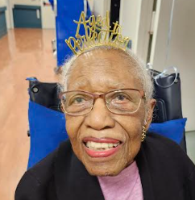

Testimonial from Nancy and her family in Amityville, New York.  
"Thank You, **National Association of American Veterans, Inc. (NAAV)** for  
send me my beautiful birthday flowers. Thank you for your continued  
support and professional assistance to me and my beloved family members  
over the past ten years." - **Nancy Leftenant-Colon, Major, U.S. Air Force  
Nurse Corps (Retired), Amityville, NY**

December: *Joy in sorrow*

NAAV provided emergency resources and referrals to Shylonda Sampson on December 26, 2024.

*“Happy Holidays and thank you so much for all of your assistance and information.”*

"*Hello NAAV, Inc. Joy of the Christmas Season to You! Thank you so much  
for your encouragement cards, prayers and support during these  
challenging times. My Dad is improving, and we have submitted our  
application for the VA Caregiver Support Program. Our doors are always  
open to NAAV, Inc. God's blessings and cheers to a wonderful 2025! You  
have a wonderful purpose and nonprofit organization!"* - **Kenneth Davis,  
Pro-Cuts Editing, Maryland**  
"*Dear NAAV, Inc. and Constance Burns, thank you so very much for your  
recent gift to bless, comfort, and defend the suffering people of Israel  
through your support of the Jerusalem Prayer Team. The work that we are  
doing together to help God's Chosen People in this prophetic crisis  
moments is making a huge impact, showing true Christian love in action  
to the entire nation. Thank you again for sending your generous gift  
this month. God bless you with His favor and grace."* -- **Dr. Michael D.  
Evans, Ambassador to Jerusalem and Founder/CEO, Jerusalem Prayer Team  
International, Phoenix, AZ**

**Going the Distance --Mortgage and Rental assistance:**

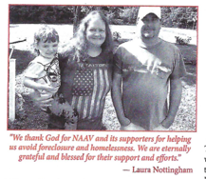NAAV provided a donation check in the amount of $500.00 to place toward the amount owed by Thomas Southworth, a veteran most in need residing at the Frederick Courts Apartment in Reno, Nevada. Again, NAAV donated over $2,000.00 to stop foreclosure and homelessness for Jeff and Laura Nottingham in Jamestown, Tennessee.

… Just in time before a snowy winter in Vermont: NAAV steps in --

“*Dennis Breault, Sr., and his three daughters with their Toyota Forerunner that NAAV,  
Inc. helped him acquire, just in time before the snow! They live up on a  
big hill in Vermont and needed a 4-wheel drive just to get up and down  
the driveway.  I’ve known Dennis for 25 years or more. He is a great  
friend, a wonderful father to his girls and a strong man of faith. Thank  
you for all you’ve done for him, and I may need to inquire about your  
services as well! I am a Desert Storm veteran and have no idea how to  
proceed with all of the info I keep hearing about the PACT act. Thanks  
for your help! - Jay Vonderahe, Retired U.S. Armed Service Veteran  
  
"Thank you NAAV, Inc. and our Lord God for my spiritual wellness DVDs,  
books and materials received today for the Christmas Holidays. Thank you  
so much and thank you for helping me get the vehicle in November. It's  
beautiful. It's awesome! Thank you for helping so much for how you  
worked with the White River Toyota Managers and what you did for me and  
my beloved three daughters Linda, Tricia and Daisy we will never forget  
your organization." -* ***Dennis Breault, Sr., U.S. Navy (Retired), Vermont***

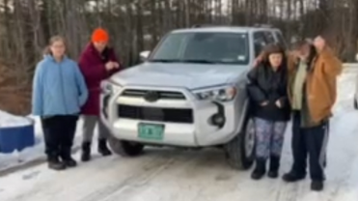

Thank you for taking the time this year to share, pray, and support NAAV as we continue to serve our Veterans, their care givers, and family members. 2024 has truly been an up and down year, but once again by God’s grace and with your help our hands and hearts were open as we received and gave unto others in much needed circumstances… We can’t say thank you enough for journeying with us. Let’s walk into 2025, trusting God to do what only He can do!

Wishing you and yours a very Merry Christmas, safe, prosperous and blessed New Year!

In His Service,  
Constance A. Burns  
Founder, President and CEO  
Veterans Service Officer

Chair, Board of Directors  
**National Association of American Veterans, Inc. (NAAV)**  
P.O. Box 6865, Washington, DC 20020-0565  
Office: (202) 465-3296  
Mobile: (202) 355-3879  
Email: [**info@naavets.org**](mailto:info@naavets.org)Website: [**www.naavets.org**](http://www.naavets.org/) click on Donate Today! Thank you.

CFC #85065 "Caring About Those Who Served"  
GIVE HAPPY TODAY visit [**www.GIVECFC.org**](http://www.givecfc.org/)to donate. Thank you.