**NATIONAL ASSOCIATION OF AMERICAN VETERANS**

**October > November > December 2024**

**Winter 4th Quarter Newsletter**

…Falling leaves all around. Falling leaves on the ground. Just like we might fall, we can get back up and turn our life around.

The ground isn’t the end of a thing. Rather, hitting the ground is a brace; a stop gap; a spring to step, not to quit, but as a pause in-state of being: to wait—regroup and transition to the next thing.

Something to ponder as Mary did that day the Angel Gabriel came to visit and told her, “do not be afraid, you shall bear a child (son), while a virgin. She has found favor with God.” {Luke 1:26-38}

Something to ponder:

What happens to a leaf that falls to the ground—have you ever wondered? It doesn’t necessarily die, but instead, “bounces back for a new and hopeful purpose”

Mary replied: “…be it unto me according to thy word. {Luke 1:38 – KJV}

Volume IV

Welcome to the 4th Volume of **The National Association of American Veterans (NAAV) Inc**., end-of-year Winter 2024 Newsletter.

As fall has fallen away from its orange, amber, and brown days with warm sunshine ending in a crisp renewal of air, we sense a chill, a slowing down in contemplation that the end of an era is lurking, but yet it’s not the end. Instead, it’s the beginning of “out with the old—into the new.

Winter must come to put a freeze on the past. Fall was left dormant for winter to cover, preserve and transition to a fresh season of dawning… A new year will be upon us.

NAAV’s last few months of 2024’s transition – In pursuit of the “leaves. https://encrypted-tbn0.gstatic.com/images?q=tbn:ANd9GcR49_ZgXI6efjvChR4ANpd03DBRTDt_j9CAw&s

*Transition with us into the next season:*

* *Veteran’s News*
* *Veteran Resources*
* *NAAV by the numbers*
* *A season of giving*

This 4th quarter volume NAAV newsletter is dedicated to the notion of transition. It’s our way of showing and sharing the good part of balling as falling typically reacts to “getting back up, turning around, changing and or leaving the scene. We say, okay, that was a bump… I just fell… or “…be it unto me,” I accept that, “strange thing that has happened.”

We carry on, perplexed yet entering something different, changing our direction with everything still in tack recognizing and developing a few new perspectives. A new shape. A new color. A new purpose.

Let’s learn from the fallen leaves in transition this season and like a “taproot” hold on and remain strong, steadfast, immoveable, always abounding in the work of the Lord, because yours, mine, our labor is not in vain. {1 Corinthians 15:58}

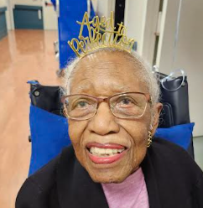

**Veteran News**

Happy 104th Birthday to Major Nancy Leftenant-Colon, U.S. Army/Air Force Nurse Corps (Ret).

The First African American Nurse **– Nancy Leftenant-Colon, Major (Retired)** was the first African American nurse to served in the reserve or active-duty Army/Air Nurse Corps, the precursor of the Air Force. She joined the Army Reserves in 1945, unable to get into the regular Army Nurse Corps because she was an African American. The only woman to become the first president of the Tuskegee Airmen, Inc. from 1989-1991. Along with selected members of the Tuskegee Airmen, she received the **Congressional Gold Medal**from President George W. Bush on March 29, 2007.

* Army Cuts Credentialing Funds For Soldiers As Demand Surges.
* Free virtual initial claims at the VA clinic for Women Veterans
* Tips for veterans facing employment crisis

*visit [www.naavets.org](http://www.naavets.org) for more details

www.Naavets.org

Veteran Resources

*“Happy Holidays and thank you so much for all of your assistance and information. *Dec – Emergency resources*

*Dual Diagnosis: Managing Substance Abuse and mental health as a Veteran \**Posted in [A Source for Women Veterans](https://www.naavets.org/category/a-source-for-women-veterans/), [Military Family](https://www.naavets.org/category/military-family/), [Organization News](https://www.naavets.org/category/organization-news/), [Resources](https://www.naavets.org/category/resources/), [TRAUMATIC BRAIN INJURY AND MENTAL HEALTH](https://www.naavets.org/category/traumatic-brain-injury-and-mental-health/), [Veteran News](https://www.naavets.org/category/veteran-news/), [What's New](https://www.naavets.org/category/whats-new/)

Naavets.org

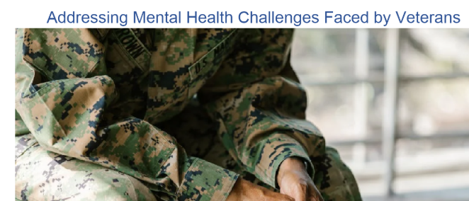

 *Serving American Veterans (Marty Adam’s new 4Runner for Dennis Breault, Sr., U.S. Navy, Veteran. Thanks to NAAV and White River Toyota in Vermont for assistance (Dec 2024):

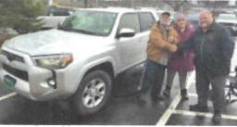 *"I Thank God and NAAV, Inc. for being with me and my three beloved daughters over the past 4 years. We thank you  
so much for your continued support and professional assistance on behalf  
of those who served in our nation's Armed Forces worldwide. Thank you  
for helping me get the SUV vehicle shown the video sent to NAAV, Inc. in  
December 2024. It is beautiful. It is beautiful! It is Awesome! Thank  
you, NAAV, Inc. for helping so me and my family at the White River  
Toyota in Vermont on November 24, 2024. Merry Christmas and Happy New  
Year!"* -- Dennis Breault, Sr., U.S. Navy (Retired), Thetford Center,  
Vermont.

The **National Association of American Veterans, Inc. (NAAV)** was established in 2005 and incorporated in 2006 to provide programs and services for those who served and are serving in the U.S. Armed Forces worldwide most in need of emergency assistance with transportation,   
shelter, rent, mortgage and utilities bills to name a few.

***NAAV by the numbers:***

*This year NAAV has made strides despite the noticeable lull in giving to support and come to the aids of our Veterans and their family members in miraculous ways…* ***For unto us****… God has given grace.* ***For unto us****… God has made a way…*

* Number of Visitors to NAAV website: 2024 over 1 million  
    
  Calls to Corporate Office calls for 2024 over 5 thousand  
    
  Calls to CEO and Veteran Service Officer over 2,500  
    
  Suicide calls 4 for 2024, the latest call received the second week in  
  December.  
    
  Homelessness calls nationwide over 100 calls  
    
  Calls for NAAV Emergency Assistance Resources and Referrals over 2,000 nationwide.
* *To date, we have received an estimated $47,500.00 of donations in  
  support of those who served and are serving in the U.S. Armed Forces.*

*https://www.google.com/url?sa=i&url=https%3A%2F%2Fstockcake.com%2Fi%2Ffrosty-holly-berries_1339513_867693&psig=AOvVaw1gKxc-8189Cfd0T_be_h6S&ust=1735416171405000&source=images&cd=vfe&opi=89978449&ved=0CBQQjRxqFwoTCLCjtJ_fyIoDFQAAAAAdAAAAABAE*

**Highlights**:

NAAV featured in charity organization’s website and Charitable Choices 2024 Holiday Guide for financial support provided to a veteran and family members in Jamestown, Tennessee:

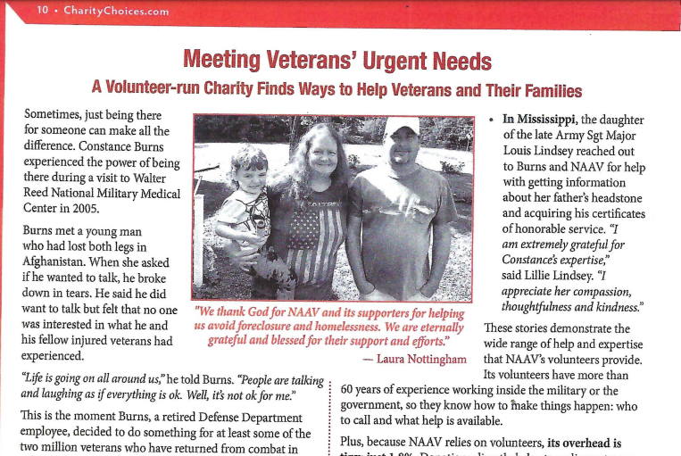

Visit NAAV website at [**www.naavets.org**](http://www.naavets.org)for more details and a full article.

Featuring a Season of Giving:

NAAV's Year-End Fundraising Campaign and Combined Federal Campaign is  
one of its most important sources of support. To give generously by or  
before December 31, 2024, please visit [**www.naavets.org**](http://www.naavets.org/) click on Donate  
Today! If you are a federal employee or retiree, you may visit GIVE  
HAPPY TODAY at [**www.GiveCFC.org**](http://www.givecfc.org/) by January 15, 2025, to donate. NAAV's  
CFC number is 85065, "Caring About Those Who Served." Thank you in  
advance for your continued support and professional assistance.

Your year-end contribution will make a difference in the lives of those  
recovering from severe injuries and those needing emergency assistance.  
Can we count on your gift of $500, $1,000, $2,000, $5,000 or more? It  
all helps. Many thanks, from the NAAV nonprofit organization for your  
continued support. Thank you.

*Her smile is worth *1000 words!* Your contributions to matter!

 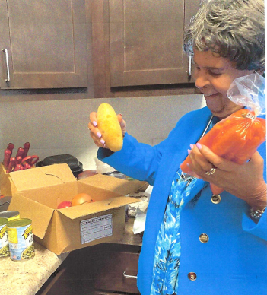*Charitychoices.com

Central Union Mission –



 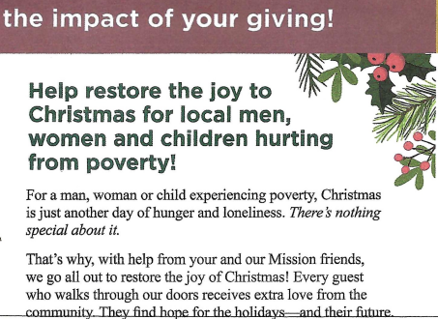

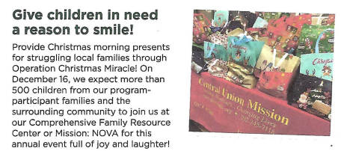… *You should know, that your love isn’t lost… Your love in giving is never wasted*…NAAV, Inc.

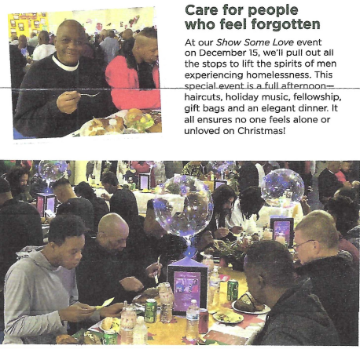

**A prayer for this season:**

Lord, thank You for Your faithfulness to us. Make us mindful of those who need our help and

encouragement. Help us go forth to serve You renewed and strengthened by Your mercy and grace this

joyous new year. And help us to help those most in need. Lord, You are all-loving, all-seeing, all-knowing,

and all powerful and we know that You always have our best interest at heart. And in You there are no

mistakes. When we are overwhelmed by challenges help us to cast all our cares upon You and to trust in

You to meet all our earthly needs. When we are burdened with anxieties and stress and when

nightmares trouble our sleep, please restore our peace, I pray. Teach us how to rest in the shadow of

Your wings. Keep us in your ever-loving hands. In Jesus’ name, I pray. Amen.

All Scripture verses are taken from the New King James Version of the Holy Bible.

By Constance A. Burns, NAAV Volunteer Contributor for Moments of Meditation and Scripture Readings;

email: cburns@naavets.org.

We hope this good news and encouraging feature keeps you in the rhythm and season of giving towards NAAV’s mission to support and care for our Nation’s Veterans and their family members imparting hope and gratitude that there might truly be a known “joy to the world… For the Lord has come… Let earth receive her King… Let heaven and nature sing… Praise God and thank you, Jesus!”

Join NAAV in its season and belief that we leave no one behind. Let us accept this strange challenge to believe and make way for the New Year for what might look like it is dying, rise from the frost in rebirth – In 2025 – Keeping it real. Keeping it alive!



https://www.google.com/url?sa=i&url=https%3A%2F%2Fstockcake.com%2Fi%2Ffrosted-holly-berries_1339515_867693&psig=AOvVaw1gKxc-8189Cfd0T_be_h6S&ust=1735416171405000&source=images&cd=vfe&opi=89978449&ved=0CBQQjRxqFwoTCLCjtJ_fyIoDFQAAAAAdAAAAABAJ

Merry Christmas and most assuredly a blessed and prosperous New Year!

Warmest regards,

Constance A. Burns

Founder, President and CEO

NAAV, Inc.

Washington, DC

