|  |  |  |  |  |
| --- | --- | --- | --- | --- |
| **Volume 03 24 | Issue 3 | National Association of American Veterans (NAAV), Inc.July ~ August ~ September 2024** |  | |  | | --- | | The National Association of American Veterans, “Sunflower: The Eye of Sunshine” | | e: July, August, September 2022 | |
|  |  |  |
|  |  |  |
| NAAV INC., Newsletter 3rd Quarter Review 2024 |  | In This Issue – Rewards of giving |

NAAV in the Eye of Sunshine

Editor’s notes: Welcome to this summer’s 3rd Quarter issue of the **National Association of American Veterans (NAAV)** Newsletter 2024. We have features highlighting care for veterans, summer testimonies, available resources, and announcements advocating for your generous continuation of financial support that will enable us to continue our veteran service mission.

NAAV is proud to spread sunflowers joy to our American veterans and their family members. Thank you for joining us during this season. Your time, talent, and treasures are most needed and appreciated. Read on to see how NAAV has been able to grow tall as a sunflower enriching lives and spreading joy to our nations veterans and their family members through resources and spreading the good news of opportunities for support.

{AI}-Sunflower fact: How sunflowers follow the sun: **Pollination:** Sunflowers face east in the morning to warm up and attract pollinating insects, like bees; **Growth**: Sunflowers use the sun's heat to grow, and they track the sun's movement throughout the day to get more sunlight; **Hygiene:** Facing east helps sunflowers dry out faster from dew; **Circadian rhythm**: Sunflowers have an internal clock that controls their growth, and they use it to anticipate sunrise and rotate 180 degrees overnight to face east. **Stem growth**: Sunflowers' stems grow more on the side facing the sun, which causes the flower to tilt in that direction. **Maturity:** As sunflowers mature, their growth slows down and they stop following the sun, settling on facing east permanently. So as you can deduce, from the facts, sunflowers take in [the sun] to give out [light and life]. NAAV hopes to do the same. Our mission is a cycle of getting and giving… Reaping and sowing… **Spreading seeds of life with your support**.



Sowing the Seeds of Giving

# NAAV is a proud recipient of the Combined Campaign Fund, (CFC). Established in 2005 and incorporated in 2006, NAAV endeavors to provide support for our nation's service men and women, disabled veterans, their caregivers and family members most in need nationwide.

# For many veterans, their caregivers, and family members sharing life with family members and friends is a treat. But for most military families in need, it can be a challenging time choice to make. With the rising cost of food, thousands of veterans will find it especially difficult to afford food for hospitality. Instead of preparing for holiday gathers, most veterans and their family members are seeking emergency assistance from public charity organizations like the NAAV to assist with food, rental, mortgage, utility, and homelessness nationwide.

# With your continued support, we are planning to help many military families have meals over the holidays this year. I know that providing assistance to thousands this year with holiday meals is a lot; however, I believe all things are possible through Jesus Christ our Lord. Can we count on your donation of $10, $15,

# $20, $25, $50 or more to give to NAAV that will support of NAAV partners who are preparing meals for those who may go without a holiday meal? Every dollar you give helps provide at least 10 meals for families most in need. Your generous contribution of $25 helps provide food for 250 meals and a donation of $50 will help provide food for many more meals for families including the homeless. Thankfully, our veterans and their families will have joyful holiday meals and receive emergency assistance when they call. Thousands of veterans and their family members can use a little extra help right now. You can lean towards the sun and lend a helping hand by: \***\*\*Making a generous gift online at**[**www.naavets.org**](http://www.naavets.org/)**click on DONATE TODAY or Give via the 2022 Annual CFC NAAV’s Number 85065** **visit** [www.GIVECFC.ORG](http://www.givecfc.org/) or [www.cfcnca.org](http://www.cfcnca.org/) **to donate**.

# 

\*We cannot thank you enough!

***Parable: Lessons of Sowing and Reaping***

***Featured in summer 2022: Have you ever read the parable about sowing and reaping? Do you believe this is a measurable concept? In the book Matthew, chapter 13, Jesus taught His disciples the principle of sowing and reaping. He shares in verses 1-9 (NIV) ~***

**The Parable of the Sower**

**13**That same day Jesus went out of the house and sat by the lake. **2**Such large crowds gathered around him that he got into a boat and sat in it, while all the people stood on the shore. **3**Then he told them many things in parables, saying: “A farmer went out to sow his seed. **4**As he was scattering the seed, some fell along the path, and the birds came and ate it up. **5**Some fell on rocky places, where it did not have much soil. It sprang up quickly, because the soil was shallow. **6**But when the sun came up, the plants were scorched, and they withered because they had no root. **7**Other seed fell among thorns, which grew up and choked the plants. **8**Still other seed fell on good soil, where it produced a crop—a hundred, sixty or thirty times what was sown. **9**Whoever has ears, let them hear.”

**10**The disciples came to him and asked, “Why do you speak to the people in parables?”

**11**He replied, “Because the knowledge of the secrets of the kingdom of heaven has been given to you, but not to them. **12**Whoever has will be given more, and they will have an abundance. Whoever does not have, even what they have will be taken from them. **13**This is why I speak to them in parables:

“Though seeing, they do not see;  
    though hearing, they do not hear or understand.

**14**In them is fulfilled the prophecy of Isaiah:

“‘You will be ever hearing but never understanding; you will be ever seeing but never perceiving.  
**15**For this people’s heart has become calloused; they hardly hear with their ears, and they have closed their eyes.  
Otherwise they might see with their eyes, hear with their ears, understand with their hearts and turn, and I would heal them.’[[a](https://www.biblegateway.com/passage/?search=Matthew%2013&version=NIV#fen-NIV-23555a)]

**16**But blessed are your eyes because they see, and your ears because they hear. **17**For truly I tell you, many prophets and righteous people longed to see what you see but did not see it, and to hear what you hear but did not hear it.

**18**“Listen then to what the parable of the sower means: **19**When anyone hears the message about the kingdom and does not understand it, the evil one comes and snatches away what was sown in their heart. This is the seed sown along the path. **20**The seed falling on rocky ground refers to someone who hears the word and at once receives it with joy. **21**But since they have no root, they last only a short time. When trouble or persecution comes because of the word, they quickly fall away. **22**The seed falling among the thorns refers to someone who hears the word, but the worries of this life and the deceitfulness of wealth choke the word, making it unfruitful. **23**But the seed falling on good soil refers to someone who hears the word and understands it. This is the one who produces a crop, yielding a hundred, sixty or thirty times what was sown.”

**This year during 2024, NAAV continues to call upon its readers to hear about the goodness of grace and mercy many of you have already shared through your giving and multitude of ways this organization has been blessed our sponsors, readers, and volunteer’s generous gift of time, talent, and resources. Thank you for hearing then bending, for seeing then trusting, by taking a step to believe in our organizations mission to help, heal, and preserve the dignity of our American veterans and their family members.**

**The parable about sowing found in Matthew is, although spiritual in nature, is a way of shining the light in all our hearts to serve like a sunflower with eyes that can see and ears that can hear, and hearts spilling over with love and enough to share with others. Others who don’t ask for much, but who are deserving of more. Thank you for your continued support, generosity, and consideration to partner with this organization. Let not your heart only be warmed by the summer heat, but also by the “Son’s” grace and love. Be intentional like a sun-filled sunflower.** 

****

***News, Resources, & Media Highlights***

* **Financial Relief Announcement**



Despite their service to our country, veterans often struggle to find financial security or stability upon their return to civilian life. Whether a veteran was enlisted for a few years or for their entire career, adjusting to life after service and learning how to successfully manage money as well as navigate debt can be challenging. Unfortunately, there is a very wide range of challenges veterans may face. These challenges can result in financial mismanagement, both during service and immediately following that can cost veterans. Paying off debt, fighting the effects of fraud, and trying to build up some savings can take many years, leaving veterans insufficiently prepared for and therefore vulnerable when they retire. A lot of the resources here are geared towards helping veterans minimize debt and maximize savings so that they are well-positioned for retirement.

While the exact services offered frequently evolve, the good news is that there are options for veterans and their families to find support. But assumptions about what services are available may be mistaken. Reaching out the groups listed below could uncover additional resources offered by these organizations, or by ones they recommend.

While this piece does not aim to provide any financial advice, it does aspire to share resources to connect veterans and their loved ones with professionals who can provide assistance or further information. It also might help introduce the names of some programs and services to guide further inquiry. Click the link here at [**https://youtu.be/M32PppfQNHA**](https://youtu.be/M32PppfQNHA)or visit NAAV.org/resources for more information and resources.

\*Financial literacy is an important tool designed to help military members prepare for the day they reintegrate into society. With so many financial problems that plagued military personnel over the years, the programs provided by the government through laws like 10 U.S.C. 992 have given relief to veterans. Learning how to manage your debt, you can take some advice from reputable debt settlement companies, create a budget, and find a job and skills that should help you establish your finances once you leave the military.

* **News and Veteran Resources**
  + **Assisted Living for Seniors:**

If you're looking for local options, there is a great assisted living community for seniors in Burlington that provides dedicated services to meet the needs of older adults, including veterans.

**Links for this page:**[**https://www.naavets.org/assisted-living-benefits-for-veterans-2/**](https://www.naavets.org/assisted-living-benefits-for-veterans-2/)[**https://addingtonplaceburlington.seniorlivingnearme.com/living-options/assisted-living**](https://addingtonplaceburlington.seniorlivingnearme.com/living-options/assisted-living) **Anchor text:   assisted living community for seniors in Burlington.**

* + **Link between COVID-19 and Alcoholism**

The website below provides information on the link between COVID-19 and  
alcohol abuse. It discusses how the pandemic has led to an increase in  
alcohol consumption, as well as the risks associated with alcohol  
abuse. The website also provides resources for people who are  
struggling with alcohol abuse, including treatment options and support  
groups: <https://www.northernillinoisrecovery.com/covid-and-alcohol-abuse/> (Bonnie Andrew)

* **NAAV Maintains the Numbers – Your donations count!**
* **Spiritual Wellness and Meditation – Set your mind at ease… Choose to check-in:**

The **National Association of American Veterans, Inc. (NAAV)** is blessed to be able to

provide Spiritual Wellness messages, Scripture Readings, and Moments of Meditation to

those who served and are serving our nation far from their home. You and your family

members and caregivers are not forgotten. Always know that our LORD God knows the

challenges, dangers, and difficulties you face every day. God’s Word offers you

encouragement, hope, comfort, protection, peace, healing and much more. Please know

that we are praying for you that God’s Word will be your daily guide and throughout

your journey on earth.

**LOVE**

“For God so loved the world that He gave His only begotten Son, that whoever believes

in Him should not perish but have everlasting life. For God did not send His Son into the

world to condemn the world, but that the world through Him might be saved.” **(John**

**3:16-17)**

**JOY**

“…Weeping may endure for a night, but joy comes in the morning.” **(Psalm 30:56)**

**PEACE**

“For unto us a Child is born, unto to us a Son is given; and the government will be upon His shoulder. And His name will be called Wonderful, Counselor, Mighty God, Everlasting Father, Prince of Peace.” **(Isaiah 9:6)**

**HEADS UP:**



Kenneth Davis, Director of Post Production  
Pro Cuts Editing Services  
(301) 464-5067 / (443) 274-6115 (Main Office) / (410) 353-2192 (Mobile)  
(877) 827-6402 / (443) 274-6060 (FAX)  
[kgd@procutsediting.com](mailto:kgd@procutsediting.com) / [kgd\_procuts@yahoo.com](mailto:kgd_procuts@yahoo.com)  
[www.procutsediting.com](http://www.procutsediting.com/) [1]  
[www.iwantavideoeditor.com](http://www.iwantavideoeditor.com/) [2]  
  
2138 Priest Bridge Court, Suite 1  
Crofton, MD 21114  USA  
  
Like us on Facebook: <https://www.facebook.com/procutsediting> 

**Featured topics: Pro Cuts Editing &**

**Central Union Mission**

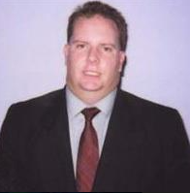

With 10+ years of experience in the film and video industry, Pro Cuts Editing is primarily operated by Mr. Kenneth Davis. Mr. Davis holds a B.A. in Communications, an M.A. in Film Production, a Web Design  
Specialist Certificate and a Certificate in Web Development. Working as  
an editor, shooter, ac, boom operator, sound recorder, sound mixer, film  
negative cutter, master control operator and researcher, Mr. Davis has refined his educational knowledge into real-life experience.

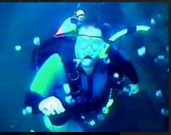

In addition, Mr. Davis is an underwater filmmaker, videographer and has certification as a PADI Divemaster (with Discover Scuba Diving Leader) plus 34 SCUBA Specialty Ratings (including one upgrade) and 2 Recognitions [1]. He is the technical expertise of this firm.

**Central Union Mission: A longtime partner**

Central Union Mission in DC Metro Area. NAAV has been a supporter for over seven years on behalf of homeless veterans.  
and their family members. See attached link:

<https://mail.google.com/mail/u/0?ui=2&ik=efe679a56d&attid=0.1&permmsgid=msg-f:1810455873251809697&th=1920080646b199a1&view=att&disp=inline>

Be the sunshine of a sunflower: *“Planting seeds of hope in places of need”*--- Turn to those in need just as the sunflower turns to the east for sun:

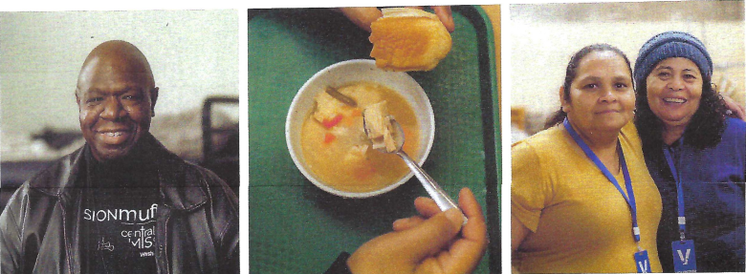



~NAAV needs your continued support:

Are you a US Military Veteran?  Are you a family member or friend trying  
to help a service member?  Are you able to make a tax-deductible.  
contribution to help NAAV continue this important work?  
  
To learn more, please visit [www.naavets.org](http://www.naavets.org/).  
To donate, please visit [www.naavets.org/donate-with-amazonsmile/](http://www.naavets.org/donate-with-amazonsmile/)   
Email: [info@naavets.org](mailto:info@naavets.org)Phone: (202) 465-3296

Please encourage your family and friends to give a monthly or yearly donation to NAAV, Inc. in support of those who served and are serving in the U.S. Armed Forces worldwide most in need. **GIVE HAPPY TODAY NAAV** **CFC #85065** visit [**www.GIVECFC.org**](http://www.givecfc.org/)to donate today. Also, visit  
[**www.naavets.org**](http://www.naavets.org/) click on **Donate Today** on NAAV website to support NAAV  
End-of-Year Fundraising Campaign. It all helps. Thank you.

**Social Media & Resources[[1]](#footnote-1): Another way to reach NAAV**

As a reminder to yourself and to share with your friends: Hello all you social media, Instagram, Facebook, and Twitter enthusiast! Spread the word NAAV’s Founder, President, and CEO also has a presence in many of those outlets. Get this, Constance A. Burns is not only known for her enduring service to our Military servicemen and veterans through the establishment of NAAV, but she is also highly esteemed amongst other platforms. Here is a triple shot of her accomplishments and ways to follow:

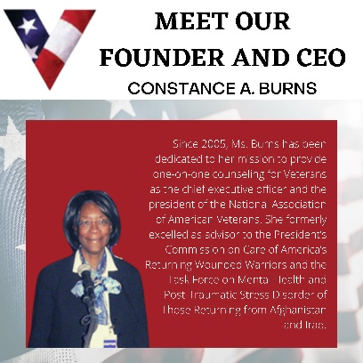 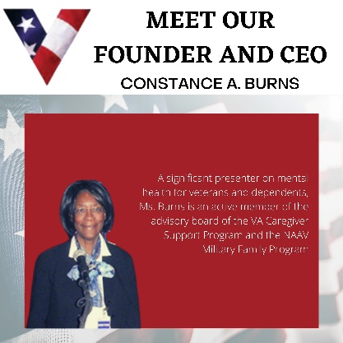 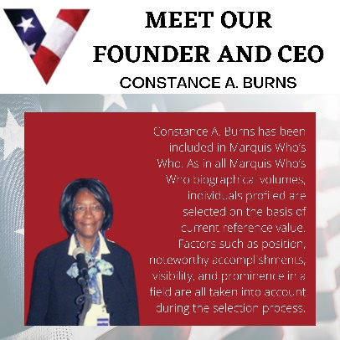

\*Images can be enlarged for better view…

NAAVets, a 501(c) (3) nonprofit organization, assisting veterans and their dependents accessing benefits.

https://static.xx.fbcdn.net/rsrc.php/v3/yw/r/zvm_GlT6_y2.png

[naavets.org](https://l.facebook.com/l.php?u=http%3A%2F%2Fwww.naavets.org%2F%3Ffbclid%3DIwAR2453QY06FdihQ8i8Wm5PASwGxNQWGWyIPcs6bCF0YaAUkZerkN5H8i0g8&h=AT3jP-3d4Rc8vrmsGmvUERY-hNpsXwYDty9znP4BwuO12Wd5BpmIHfP6DfgFwXH_ro2ZQYqyD3_tZvV9Z4HddRtnV-WGCF6rP-ZDPcrEjqq8kUHFVRXJ5i5rawdl29EhgMiV31c6O6QyRhxg8xeiAQ" \t "_blank)



Featured Testimonial:

* Summer 2024
  + *I would like to thank Constance A. Burns for saving our home. She is  
    very knowledgeable about the importance of us keeping our home. As well  
    as our son. We are eternally grateful and blessed for her support and  
    efforts. My husband and is a veteran who served his country proudly. We hope that  
    Ms. Burns efforts continue to help more families like ours.*

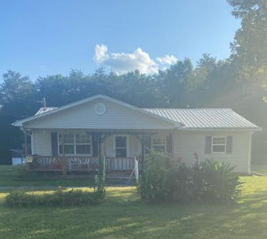 *“NAAV, Inc. President and CEO helped Laura Nottingham, and her disabled veteran spouse make settlement arrangement with the Matt Daugherty, Vice  
President and Special Assists Manager at Smart Bank to keep their home  
from foreclosure this month. NAAV, Inc. paid $2,281.79 on September  
16, 2024.”*

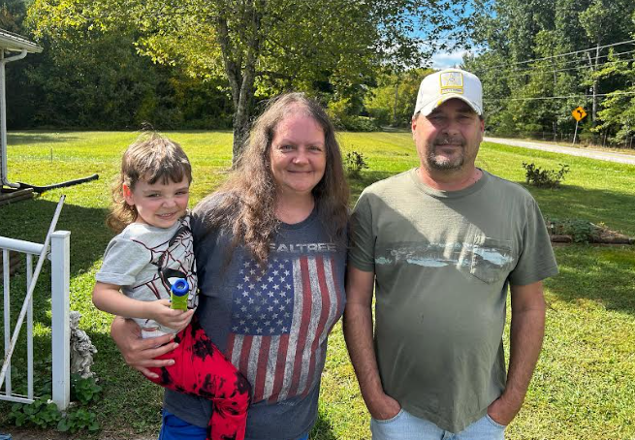

*.*

Keep an eye on the sunflower  
as it takes in the rays and absorbs the sun; it’s natural: NAAV never tires of saying thank you and to acknowledge that YOUR GIFTS OF SERVICE AND FINANCIAL SUPPORT – DO MATTER! Be Somebody’s Hero too!

Don’t forget…

As always, we hope you find the stories, features/resources/announcements, and encouraging testimonies in NAAV’s 3rd Quarter Newsletter and keep exercising the seeds of sowing and reaping, getting and giving, being a light to the world and field of sunflowers as we transition into the fall and winter seasons of 2024!

Stay well and be kind!

Warmest regards,

Constance A. Burns

Founder, President, and CEO

NAAV, Inc.

Washington, DC

\*Because of **YOU** – The NAAV has helped **THOUSANDS** of Veterans over the past **21 years**… Join with us today. 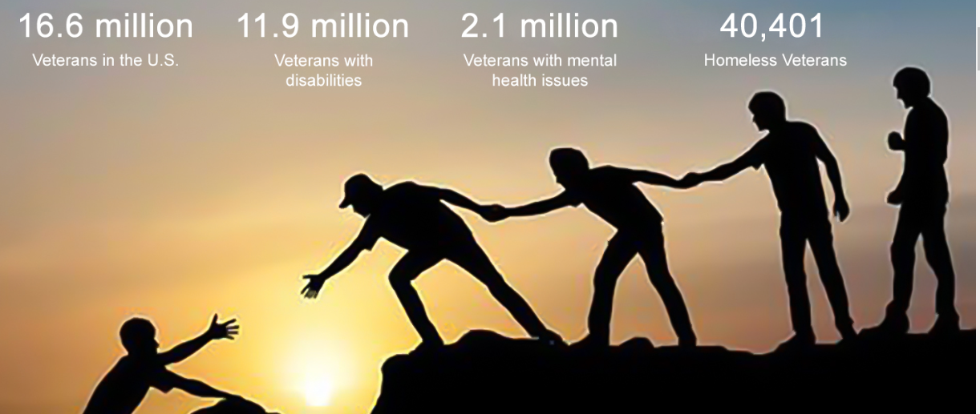

**Support the Combined Federal Campaign (CFC) by designating your gift to #85065 at**[**www.GIVECFC.org.**](http://www.GIVECFC.org.) **Or,** for more information about volunteering, please contact the NAAV Coordinator of Volunteers in determining whether your volunteer goals and objectives are compatible with those of the organization at **(202) 465-3296, option 5.**

1. Please note, NAAV does not endorse all resources provided herein; however, we are sharing as potential interest for your determination and value. [↑](#footnote-ref-1)