  - 4th Quarter Newsletter National Association of American Veterans (NAAV), Inc.
  - Issue date:
Oct, Nov, Dec 2021

Vol 4 – NAAV, Inc. |  | In This Issue

Isaiah 9:6 “For unto us a child is born; unto us a child is given…” (KJV)
Freely you have received; freely you have been given. A gift. Thank you for graciously accompanying The National Association of American Veterans (NAAV), Inc., throughout this year 2021. Once again, through your time, talents, and gifts NAAV has been able to give back to those who have given so much, and for some and their families, have given the ultimate sacrifice.
It seems once the 12th month enters into our world, it’s easy to reflect how fast time truly does fly. I am quite sure, for most of us, this year has delivered many of life’s situations to our door; some wanted while other unwanted, but yet here we are… Thankful for God’s grace and mercy.
This is our close out edition of the NAAV 4th Quarter Newsletter and it is simply packed with appreciation and one last offer for this end-of-year to freely give your gift of grace by faith. As the CFC logo reflects, “Show Some Love.”

Please take a few moments to journey with NAAV as we proudly present a few of the many gifts we have given and received throughout this year 2021, all in the name of love and passionate service of the CEO and President of NAAV, Inc. towards our American Veterans and their family members.
Her commitment and passion is driven by humble gratitude to those who have in the past, present, and future, campaigned alongside NAAV in making its foundation known by Veterans and other national service providers as an organization that cares and freely gives, because we have freely received.
Thank you for being with us in all our efforts this year. We look forward to an even stronger and dedicated New Year 2022! You are our hope!

…With great joy and tidings we bring ~ NAAV Testimonial Highlights 2021:

2021 Year-In and Out - Testimonials

NAAV received a telephone call on Friday, June 18, 2021 from a homeless disabled Veteran with 100 percent. He was requesting emergency assistance for him and his family of 7 for help with Hotel stay, food, and assistance with the VA for permanent housing.
“NAAV, Inc. with the help of the LORD and many prayers on their behalf was able to provide shelter at the hotel and food the same day.
"Thanks NAAV for providing emergency assistance for me, my spouse and family of
seven (7). Your support is greatly appreciated.”
-- Bruce and Angela
Jasmin, three children and two grandchildren, Lakeland, FL

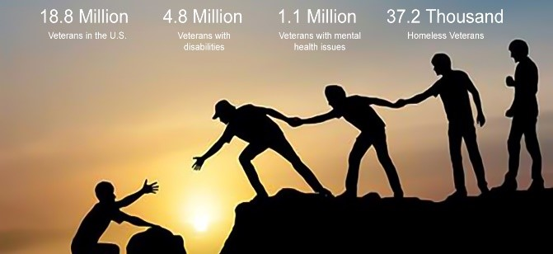
NAAV, Inc. remembers~
Rose Marie Mikolajczyk-Baker
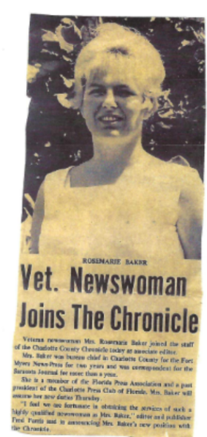

Image/painting by Rose Marie:
In My Garden

- Black History Month Award Presented to NAAV CEO/President on February 14, 2021
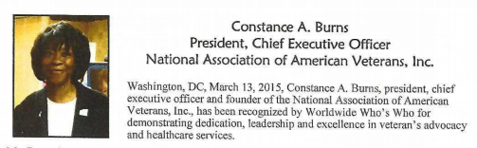
- "Thank you NAAV, Inc. for keeping my family from becoming homeless in
January 2021 by paying are current rent and talking to our landlord to
remove all of our late fees and allowing my family more time to get the
necessary funds to stay in good standing in January and February 2021.
Praise the LORD!" S. Smiley, Laurens, SC
- Dear NAAV: “On behalf of the MG Leigh Wade Chapter, MOWW, a donation of $500.00
was mailed to you today” Doug Roderick Col USAF (Ret)

Disabled American Veteran -
- "Thanks NAAV, Inc. for the complimentary DVD for chair exercises for me
and husband a U.S. Navy Veteran of the Gulf War. We appreciate your
continued support and professional assistance!" -- Charlie and Lola
Johnson, Upper Marlboro, MD

…To whom much is given, much is required…, (Luke 12:48)- NAAV would like to share this letter with you as we close out this year as a testament that your charitable contributions and giving have sincerely blessed the lives of our American Veterans and their family members.
Ramsey Family- August 2021
“Words cannot express how much Ms. Constance Burns and the National Association of American Veterans, Inc. have blessed our family. Due to the stay-at-home order, my husband and I had to remain indoors; during California’s 116-degree heatwave without air conditioning. Our broken washer and dryer cause the situation to worsen, forcing us to leave our home going to the laundromat. Weekly we were exposed to large amounts of people masked and unmasked.

The same laundromat caused one of my family members to be exposed to viral pneumonia and have back-and-forth trips to the emergency room for three days straight. The health scare was a very stressful situation, and to add to the stress, we have a roof that needs repairs, before the rainy season. We had numerous contractors inspecting the roof all had reports of bad news of how much it cost and how quickly it needs repair.

Thanks to Ms. Burns and NAAV on August 14, 2021, my family received a brand-new washer, dryer, and dishwasher including a house fan from the Home Depot in Sacramento, California. We are so grateful for the relief that the washer, dryer, dishwasher, and fan would bring. My husband and I felt blessed and that our family was not worthy of receiving anything else. However, Ms. Burns being a wonderful person, encouraged and remind us we needed a cooling device. She was thorough in servicing my family. We had the option of choosing any device from the store and with curbside delivery. That was amazing because she went over and above to keep my family cool during our recent heat advisory days.

Ms. Burns through NAAV checked in daily, gave resources, websites, and veteran services for assistance if NAAV was unable to help. If it were not for her help, I honestly do not know how my family would survive another not summer in California. My family and I are truly grateful for NAAV service, hard work, and tenacity.”

Please consider giving NAAV in your year-end tax deductible year-end giving by December 31, 2021, or through the CFC by January 15, 2022. We thank you and appreciate you.
Have a wonderfully blessed Christmas and prosperous and safe New Year to you and your loved ones.

Kind and warmest regards, Constance A. Burns NAAV, Inc.
Email: info@naavets.org
www.naavets.org

Thank you… Thank you… Thank you!
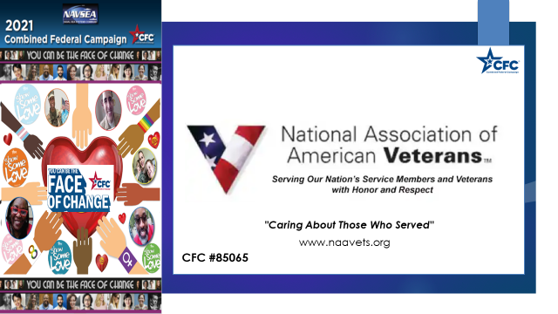

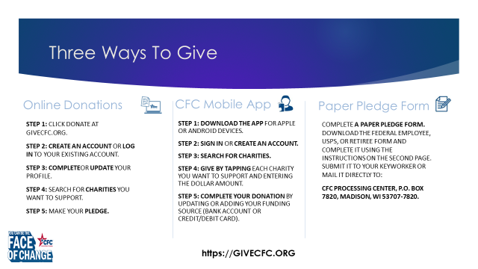

On behalf of NAAV, Inc. we wish you, a very…

